Chapter 9 - ML Algorithms - A Partial Taxonomy

A short survey

9.1 - Introduction
New machine learning algorithms used to be introduced at a breathtaking pace. However, these more recent algorithms were typically built off the core existing algorithms, tweaking certain aspects to mitigate known issues. The tweaks made the application area of these algorithms narrower, making it harder for researchers and engineers to pick the correct algorithm for the right problem. This issue was resolved partially when neural networks once again became the sweetheart algorithm of AI. This time though, advances in hardware and software meant they truly started outperforming their conventional counterparts. More importantly, they offered a more general-purpose machine learning algorithm: a one-size-fits-all, accelerating their application to many different real-world domains. As stated above, this did come with a price: neural networks are inherently complex, and therefore it will be harder to grasp how they accomplish their high performance. The mapping of the algorithmic objective (see the previous chapter) and class/type of algorithm is not necessarily one-to-one. For example, there are many regression methods, ranging from linear regression to deep belief neural networks. Below is a very non-exhaustive list of the most common machine learning algorithms and the primary algorithmic objectives we typically use them for.

9.2 - Regression Algorithms
Linear Regression | 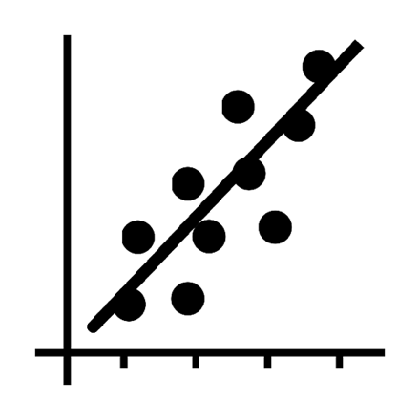
Polynomial Regression
Support Vector Machine Regression

9.3 - Classification Algorithms
Logistic Regression | 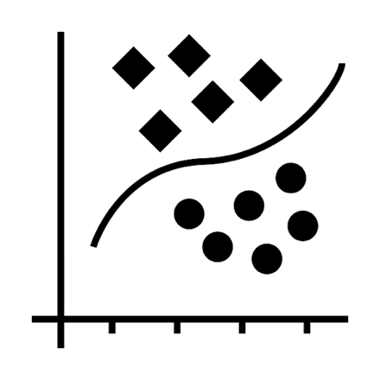
K-nearest Neighbors
Ridge Regression
Elastic Nets / Lasso
Support Vector Machine Classification
Fisher Discriminant Analysis
Decision Trees

9.4 - Ensemble Methods
Random Forests | 
Gradient Boosting
Ada Boost

9.5 - Clustering Algorithms
K-means/medians | 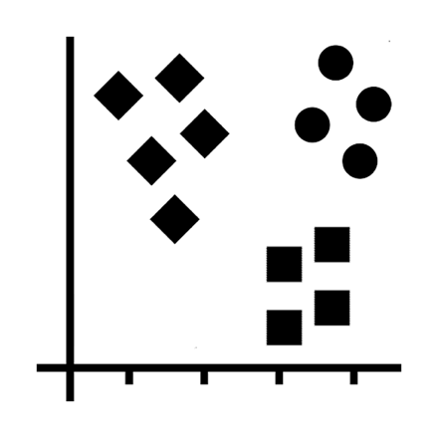
Gaussian Mixture Models
DBSCAN
Affinity Propagation
OPTICS
BIRCH
Agglomerative Clustering

9.6 - Dimensionality Reduction Algorithms
PCA | 
ICA
Factor Analysis
Autoencoders
Multidimensional Scaling

9.7 - Manifold Algorithms
tSNE | 
Hessian Eigenmapping
Stochastic diffusion

9.8 - Natural Language Processing
Latent Dirichlet Analysis | 
Hidden Markov Models
Word2Vec
Naive Bayes

9.9 - Graph Algorithms
Girvan Newman Community Detection | 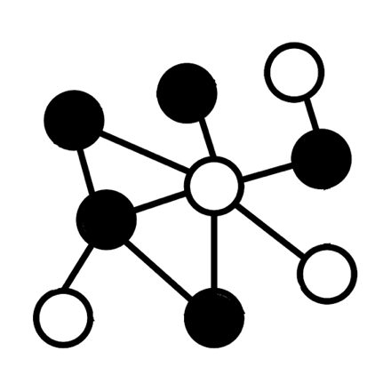
Louvain Community Detection
Minimum Spanning Trees
Dijkstra Shortest Path
Random Walks

Page Rank

9.10 - Neural Networks
Markov Chains | 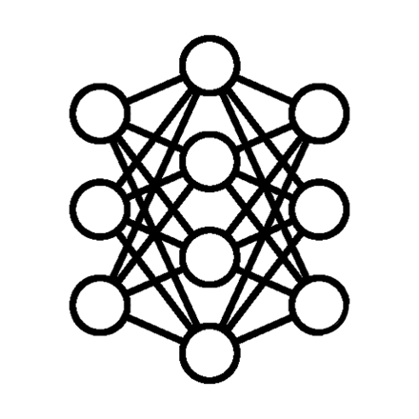
Kohonen Self-organizing Network
Recurrent Neural Nets
Deep Belief Neural Nets
Convolutional DB Neural Nets
Deconvolutional Neural Nets
Radial Basis Function Nets
General Adversarial Nets

9.11 - Niche Algorithms
Evolutionary algorithms | 
Genetic algorithms
Swarm optimization
Quantum Algorithms
AlphaGo Zero

